Child Chiropractic Health Questionnaire

Name__________________________________ Home Phone_________________________
Address________________________________ City, State, Zip________________________
Birth date________________ Age__________ Grade________ Male______ Female______
E-mail Address__________________________ Social Security #_______________________
Welcome to our office! It is well known that families who maintain strong healthy, well-aligned spines have much improved health. People whose spines are not kept in proper alignment are much more likely to develop health disorders later in life such as arthritis, illness, pain, heart attacks, strokes, even cancer.
Parent/Guardian________________________ Cell Phone____________________________
1. Most patients are referred to our office by a caring family member or friend. What made you decide to visit our office? Friend/Family Member Name_________________________ ❑ Telephone Call ❑ Yellow Pages ❑ Sign ❑ Website ❑ Presentation ❑ E-mail
2. Research shows that spinal problems often begin at birth. How old was your child when they received their first chiropractic checkup?______________________________ ❑ Never
3. Difficult, long and/or doctor-assisted births can cause spinal misalignments. Was your child born by C-section, forceps, suction cup or other device? (Please circle) ❑ YES ❑ NO
4. How long was the actual labor and delivery time?________________________________
5. Have you ever been told that your child has a spinal curvature, spinal arthritis, or inherited spinal problem? ❑ YES ❑ NO ___________________________________________
6. Poor posture leads to poor health and often indicates a spinal problem. How would you rate your child's posture? Poor - 1 2 3 4 5 6 7 8 9 10 - Excellent
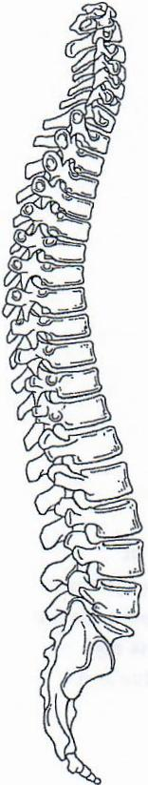
7. Did your child have early health challenges such as colic or ear infections? ❑ YES ❑ NO
8. Does your child suffer from any of the following: allergies, sinus problems, bed-wetting, difficulty concentrating, attention deficit disorder? (Please circle)
9. Does your child have other health problems that concern you?______________________ ____________________________________________________________________________
10. Do you miss work or sleep due to your child's illnesses? ❑ YES ❑ NO
11. Do you worry often about your child's health? ❑ YES ❑ NO
12. Do you have any health problems that affect your family? Please list?_______________ ____________________________________________________________________________
13. Prescription medications may cause various side effects, hide the severity of health problems and hinder the body's ability to heal. What medications is your child currently taking?______________________________________________________________________
14. Falls, sports impacts and auto accidents can cause serious spinal problems. Is this visit related to an auto accident or injury? ❑ YES ❑ NO Date of Incident____________________
15. If the doctor feels that your child will benefit from chiropractic care are you willing to follow his/her recommendations? ❑ YES ❑ NO
The above information is true and accurate to the best of my knowledge.
Parent/Guardian Signature___________________________ Date______________________
Rev. 03-8-06

